Ideation Phase

Brainstorm & Idea Prioritization Template

Date | 04 August 2026
Roll Number | 23A51A05B2
Project Name | Automated Network Request Management in ServiceNow
Maximum Marks | 4 Marks

Brainstorm & Idea Prioritization Template:
The brainstorming session was conducted to identify challenges in the existing network request process and generate possible solutions using ServiceNow. Team members collaborated to analyze user pain points such as delayed approvals, manual tracking, communication gaps, and inefficient request
handling.
Different ideas were discussed and prioritized based on feasibility, impact, automation capability, and

user experience. The selected solution focused on creating an automated network request management system that improves efficiency and transparency.
Step–1: Team Gathering, Collaboration and Select the Problem Statement Selected Problem Statement:
Manual network request handling leads to delays, repeated follow-ups, and lack of transparency in the request process.
Step–2: Brainstorm, Idea Listing and Grouping

- Self-service portal for request submission
- Automated approval workflow
- Automatic task assignment
- Real-time request tracking
- Email notifications
Final Idea:
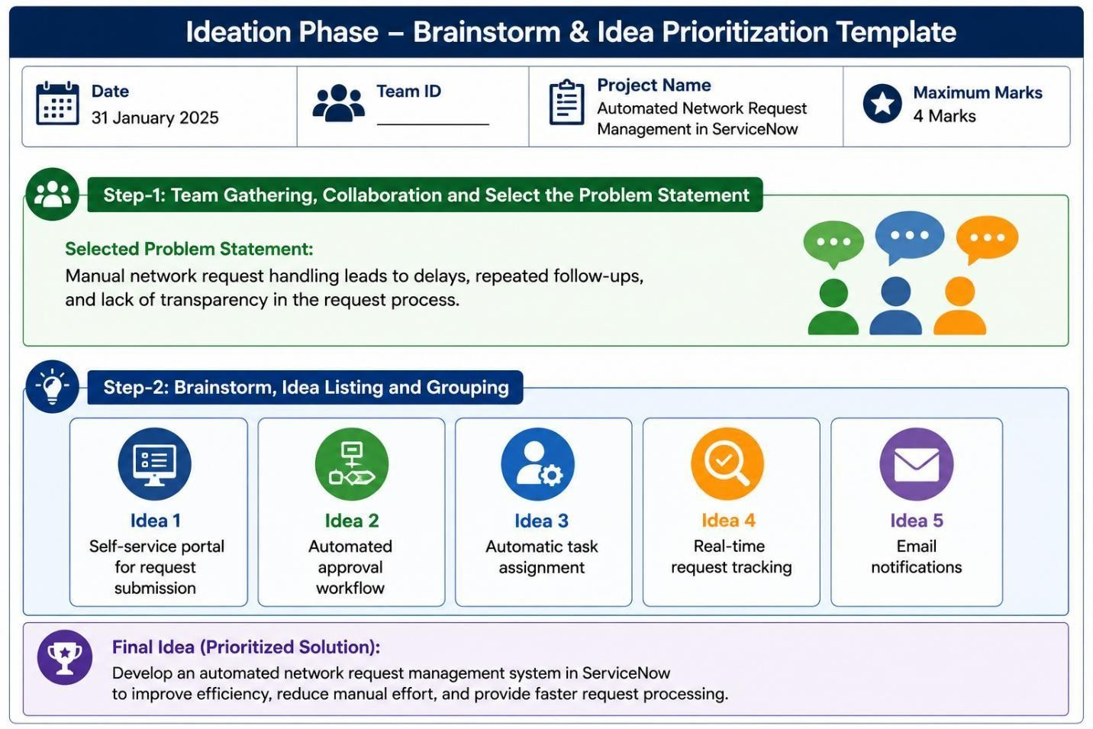
Develop an automated network request management system in ServiceNow to improve efficiency, reduce manual effort, and provide faster request processing.

